The First Tee Alumni Summit Online Application
“Quick Start Guide”

Powered by

Step 1: Enter the URL for The First Tee’s online application homepage into your browser’s address bar; it is thefirsttee.fluidreview.com. For optimal results, use Google Chrome or Mozilla Firefox as your web browser.

Step 2: Take a moment to review the information on the online application homepage (there are also links at the top of the page titled “Reference” and “Help” that provide access to reference documentation and “Frequently Asked Questions” for your convenience). Next, click the “Sign Up” button on the top right side of the page, under “Need an account?”. If you already have any account, please sign-in and proceed to Step 5.
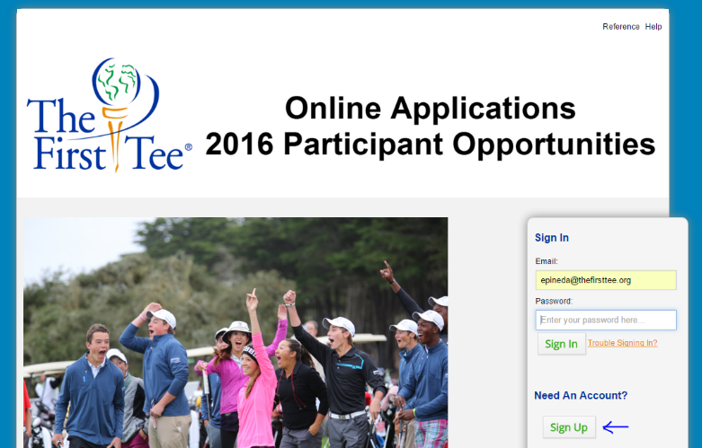

Step 3: Complete all required fields of the “Registration Form”. Please make sure that you remember your password! You can also choose to add a photo of yourself for your profile, but this is not required. When you are finished click the “Register” button at the bottom of the page.

Step 4: Once you have submitted the “Registration Form” you will end up on a confirmation page. Follow the instructions on the page to activate your account. You will receive a confirmation e-mail, at the e-mail address you used to register, from The First Tee/FluidReview and will need to click a link to confirm that you want to activate your account.

Step 5: After signing-in or after clicking the activation link in your e-mail you will be brought to the “Application Homepage”. Here you can access new applications, review completed applications and finish incomplete applications. The first thing you will be asked to do is complete the required task of entering in your “Application Code”. The application code for the Alumni Summit is ALUMNI2017. Type the code in EXACTLY as it is provided to you. Once you have your application code, click the “Start” button in the “Actions” column of your required task.

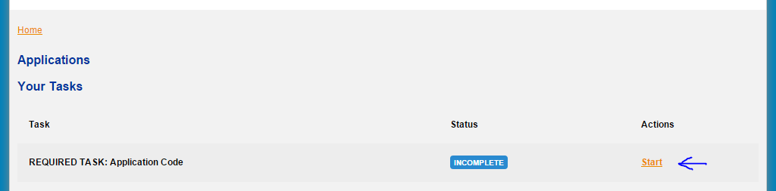

On the next page, enter your application code in the required field. If you are trying to access multiple applications, please enter each application code, separating each with a comma. When you are finished, click the “Save & Exit” button and you will be brought back to the application homepage.

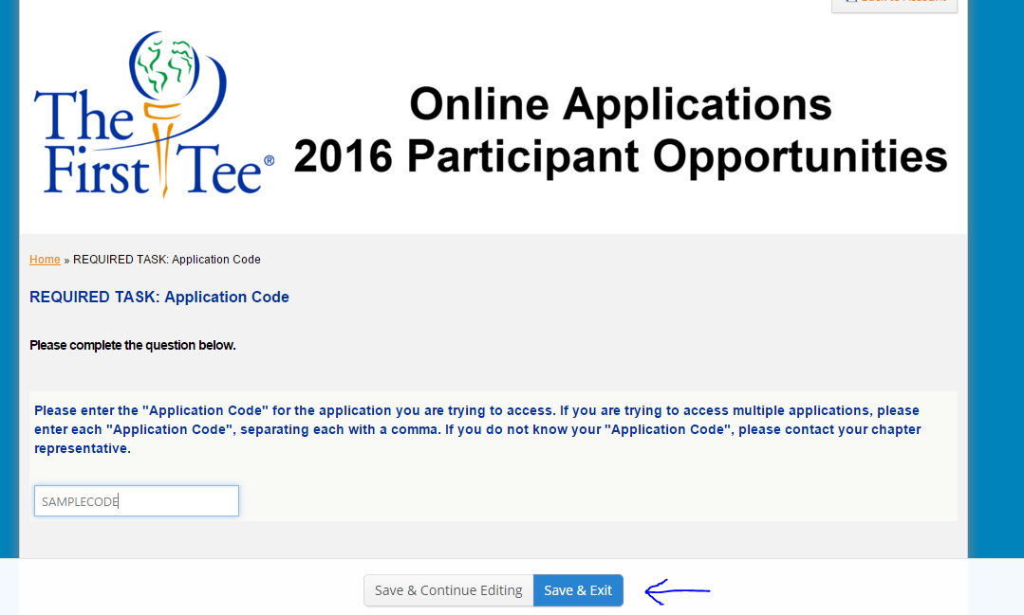

Step 6: On the application homepage you will see some new functions available after entering your application code. One is the section titled “Your Applications” this is where you will find links to completed applications for review and incomplete applications to be finished. If you have not yet filled out an application for this year, this section will be empty.

At the bottom of the screen you will see the “View Applications” button. Click this button to access and begin filling out your online application.

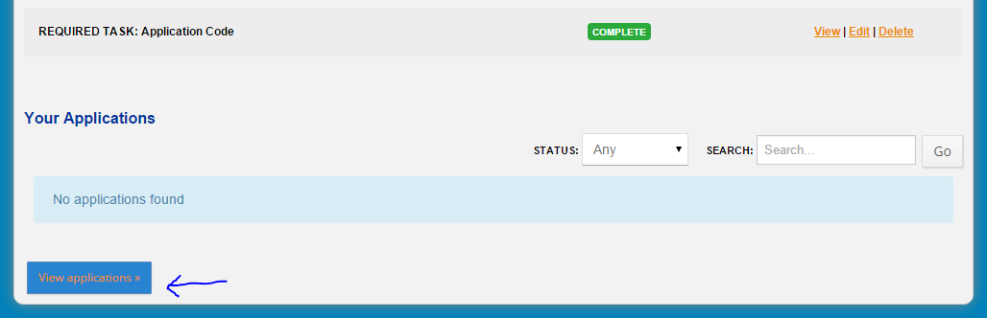

Step 7: You should now be viewing the “Applications” page. On this page you will see all applications that you are eligible for. To view information about that particular event, click on the event name in the application column. To begin filling out your application click on the “Apply Now” button.

At the bottom of the screen you will see the “View Applications” button. Click this button to access and begin filling out your online application.
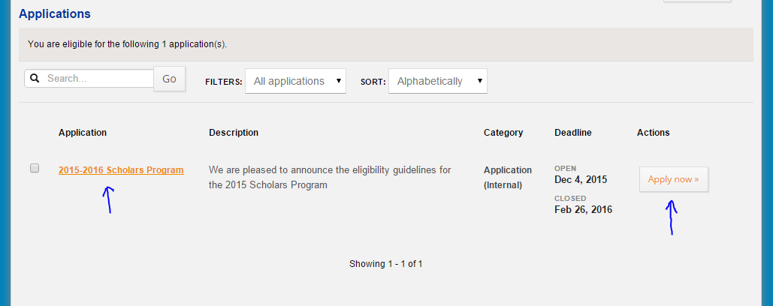

Step 8: Complete your application by completing all pre-requisite steps. Once you are finished click the “Submit” button at the bottom of the page to submit your application. If you do not finish your application you can complete it at a later date. After your application has been submitted and the deadline for submission has passed, applications will be judged and selected participants will be announced. Please refer to dates on your particular participant opportunity for more information.

